


“I will instruct you and teach you in the way you should go; I will counsel you with my eye upon you.” Psalm 32:8

Last Updated Jan. 2026

GREETINGS
Welcome to Manor Church Preschool! We’re glad you have chosen to make your child a part of our program. Your child is unique and filled with unlimited possibilities and potential. Our preschool is committed to unlocking those possibilities and to helping your child grow and develop into the very special person he/she can become. Through the goals we have set, we are confident that those promises within each child will become realities as each one grows and develops throughout the year.

GOALS
The Preschool program will work within the spirit and attitude of the Christian faith. We will strive to meet the child’s individual needs as well as group needs through a variety of experiences introducing the preschooler to question, experiment and explore at their own pace.
We will try to instill in the children, values of love, compassion, trust and understanding, and a solid belief in God. We will help the preschooler to live peaceably with other children and to value the rights and feelings of others, as well as one’s own rights.
We hope to be able to teach each child to be at ease away from home, to accept directions from adults, and to finish given tasks. We will strive to contribute positively to your child’s total development. We will give a variety of opportunities to develop gross motor skills as well as fine motor and cognitive skills.

ARRIVAL AND DEPARTURE
Morning Classes are 9:00am-11:30am
Extended Classes are 9:00am-1:00pm
Full day Classes are 9:00am-3:00pm.
Drop off will begin at 8:50am and continue until 9:15am.
Please pull up so that three cars can fit under the breezeway. An assistant teacher will arrive to get your child out of the car. Parents are responsible for unbuckling their child and helping them out of the car.
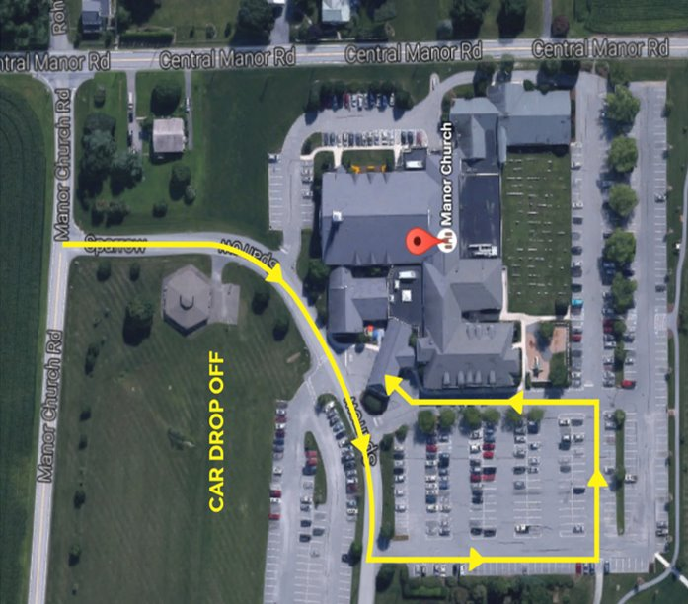
Pick up will begin at 11:20am | 12:50pm | 2:50pm.
Families will be coming into the building for pickup. After entering the church lobby, proceed to the preschool entrance where you will be checked in with your security code card and allowed access to the preschool wing. For the safety of the students and staff you will need your security card each day.
If someone arrives without the security card, and they are not listed on the pickup list, we will not release the child to the adult until we verify with the parent.
Every family will receive 2 cards at meet the teacher night, one for themselves, and one for those listed on the emergency pickup list. More can be made if necessary.

Please honor these times. If problem situations arise, please call the church office (717-285-3138). If you do not reach a live person, dial extension 229 and leave a message for Ellen Goins.

TUITION POLICY
Tuition may be received in any one of the following ways:
1. Annually – Total tuition due by the first day of preschool.
2. Semi-Annually – The first semi-annual amount is due by the first day of preschool. The second semi-annual amount is due on the first day of school in January.
3. Monthly – The first monthly payment being made by the first day of preschool. The remaining payments are due by the first of each month. Monthly payment amount includes a $5.00 convenience fee.
Checks, money orders, or cash can be sent in your child’s backpack/folder. A receipt will be sent home for cash payments. Checks should be made payable to “Manor Church Preschool”.
Fees are non-refundable for personal absences of students.
If your tuition is more than 30 days past due, your student will not be able to return to school until their account is current.

Withdrawal – Parents who desire to withdraw a child from the program need to contact the Director. Each request is handled individually.

Late Tuition Fees - Tuition reminders will be sent home after the first week of the missed month. After two missed payments a notice will be sent home and a late fee of $20.00 will be added to the balance due.

Accounts 60+ days in arrears may result in the dismissal of the student.

There is a return check fee of $20.00.
You will be unable to register for the next year until your account is current. You may also have to forfeit your spot.

SCHOOL CALENDAR
Throughout the year we try to follow Penn Manor School District’s calendar in general. However, we do not follow Penn Manor’s schedule exclusively because we serve other districts as well. Be sure to keep our calendar nearby.

WEATHER CONDITIONS
Check manorchurchpreschool.org, School Status Connect, and/or email for school delay and cancellation announcements. If there is a school delay or early dismissal, Manor Preschool will follow the Modified Schedule below.
A 1 1/2-hour delay:
• Morning Classes will be held 10:30am-12:30pm
• Extended Classes will be held 10:30am-2:00pm
• Full Day Classes will be held 10:30am-3:00pm
• Lunchbox Club will be cancelled and credits will be issued.

Early Dismissal:
• Extended, and Full day classes will end at 1:00pm.
• If need arises to close earlier, teachers will contact families.
• Lunchbox Club will still be held.

Cancellations will be made up as marked on the school calendar. We will make up the first two cancellations, any remaining missed days will not be covered.

LUNCHBOX CLUB
Lunchbox Club is an opportunity for your child in Tots, Early Learners, Next Steps, 3’s, 4’s, and PreK, to stay after school with their friends! Your child will bring a packed lunch from home that they will enjoy with their classmates and then participate in guided activities. We need a minimum of 5 students per day to run this program.
Lunchbox Club is held Monday - Friday from 11:30am-1:00pm starting in October. In the case of a 1 ½- hour delay or cancellation, there will be no Lunchbox Club held that day. You will receive a credit to use the following month. All other absences are non-refundable.
Each month you will receive a sign-up form. You may choose any number of days you wish your child to attend. The cost is $11 per day per child which is due when you return your sign-up form. Cash or checks made payable to Manor Church Preschool are acceptable. Please return forms to your child’s teacher no later than the due date listed. For planning purposes, we cannot accept forms after that date.
*We cannot monitor lunches for allergens. Sorry for any inconvenience this may cause. *

IMPORTANT REQUESTS
- An extra set of clothing should be kept in your child’s backpack in case of accidents (examples: spilled paint, etc.) Place these items in a plastic bag, clearly labeled.
- We ask that your child does not bring toys, food, dolls, gum, jewelry (not worn) or action figures to school. These items are best left at home. We cannot be responsible for what may happen to them.
- A snack will be provided each day by the preschool. We are no longer allowing outside items to be brought into the preschool for birthdays or for holiday parties unless specifically requested by your child’s teacher. Please inform us of any allergies to foods or drinks for your child. This is extremely important!
- The Preschool doors will be locked while preschool is in session. If you need to pick up your student early, you can send a note stating the time you plan to arrive, and we will have your student ready. Enter the church lobby through the main lobby doors. Enter the hallway on the right, go past the stairs and press the doorbell to the right of the brown double doors. When prompted ask for Ellen Goins or Brittany Albright. For any last-minute changes in plans, please contact the office 717-285-3138 ext. 229.
- Please be prompt in the arrival and departure of your child. Late pick-up fees will be charged for chronic late pick-ups. $30.00 will be added to your balance due after your 5th late pick-up.
- Please inform us as soon as you know of any change of address, telephone, cell phone or emergency contact. For the sake of your child, we request that your child’s teacher be informed if there are changes in your family that may affect your child’s school life. Let us know of serious illness, unemployment, separation, divorce, etc., so we can help your child emotionally during the experience. All information is kept confidential.
- Feel Free to post pictures of your child on social media from our School Status Connect, but please do not include photos of other students.

HEALTH AND COMMUNICABLE DISEASE RECOMMENDATIONS
Children cannot attend school if they have any of the following: fever, diarrhea, vomiting, a contagious disease or contagious condition (lice; hand, foot, mouth; scabies; pinworms; conjunctivitis; impetigo; etc.). Please do not bring your child back to preschool until they are symptom-free without fever reducing medication or have been given proper treatment. Students must be fever free for 24 hours prior to their return.
If a child is sick at school with any of the above symptoms or is contagious, his/her parents or the emergency person listed on their application will be called to pick him/her up immediately. Please call the church office when your child will not be attending and clarify his/her illness, particularly if contagious, so the school may initiate appropriate measures.
The Pennsylvania Department of Health has established guidelines for exclusion from school for contagious diseases. Please contact your pediatrician for an acceptable timeline to return to preschool.

DISCIPLINE
Manor Preschool employees encourage acceptable behavior by giving positive verbal rewards. This reinforces good feelings and healthy self-esteem within the child. It also serves as an example to other children to act in such a way as to receive this praise. Discipline is training that teaches one to obey rules and control one’s behavior. Discipline is an ongoing process with children and for maximum learning to occur, immediate and consistent reinforcement is important. At Manor Church Preschool we encourage self-control and responsibility for one’s own actions. Respect for each other, self, peers, and authority is taught with love and consistency. However, there are occasions when a student creates a situation in the preschool which infringes upon the rights of the other children and/or the teacher. The child needs to know that you, as parents, support us as the authority while the child is in our care. Several examples of behavior that will not be tolerated at our school are:
1. Fighting or touching others in inappropriate ways
2. Profanity and name calling
3. Destructive acts against school property
4. Creating an unsafe environment for staff and peers
5. Deliberate disobedience
6. Continued disruption
7. Harming other children or staff
The teacher will use disciplinary techniques for misbehavior that they have incorporated within their individual classroom. Some examples are redirection, better choices, elevation of warnings, withdrawing the child from the group or activity (time-out which will be limited to no more than one minute per year of the child’s age). Acceptable methods of discipline should encourage self-esteem, self-control and self-direction, using praise and encouragement of positive behavior rather than focusing on negative or unacceptable behavior. If misbehaving persists, the child will be taken to the Director’s office. If misbehavior continues to occur a parent/teacher conference will be called to discuss alternative methods of solving the problem. If there is no resolution to the issue or problem, the school will be forced to remove the child via suspension or permanent expulsion from the program.

BATHROOM POLICY
It is the policy of Manor Preschool that children in an age 3 and older classes should be toilet trained before beginning preschool unless a child has a disability. If a child has a disability or medical condition that conflicts with this policy, please contact the Director. Children should be able to use the toilet without the assistance of a staff member. They should be able to pull down and pull up their pants/skirts and underwear themselves.
We as a Preschool want to love and support our students during this period of development and understand that pull ups may still be necessary for students in our Age 3 classes. If sending your child in a pull up, they will still need to be able to pull it up and down during bathroom breaks. All students will need to be in underwear by November 1st. We understand that accidents may still happen. However, continuous accidents are a major disruption to the classroom. Chronic accidents may result in a two-week grace period where the child will remain at home to work on the mastery of this skill. If mastery is unsuccessful, your child may not be able to return at the present time.
The following guidelines are followed by all staff at Manor Preschool:
1. A teacher or assistant teacher will not accompany a child into a bathroom with the door closed. If it becomes necessary for a staff member to assist a child while in the bathroom, the door will be propped open.
2. Only females will escort/assist children in the bathrooms.
3. No minors (age 17 and under) shall assist children in the bathrooms.

SPECIAL NEEDS POLICY
Manor Preschool will make every effort to meet the needs of your child physically, emotionally, intellectually, and socially within our abilities based on our staffing, ratio, and facility resources. We value an inclusive environment that respects the distinctive qualities of others and individual aspects of themselves. We will work with families in making necessary accommodations for your child as long as we can maintain a safe and successful space for all students. We look forward to working with you at every stage of your child’s development to ensure a warm, secure environment for your child to grow and learn.

manorchurchpreschool.org
530 Central Manor Road | Lancaster PA
Phone | 717.285.3138 EXT. 229 Fax | 717.285.3130 elleng@manorchurch.org

